UT-2 (IoT)

Case Study - 10 Mks

Compare - 5 Mks

Theory Question - 5 Mks

Note: this is what i have assumed :)

**IoT QB - Answer**

Q1. Case-study:(x2)

1. IoT environment:

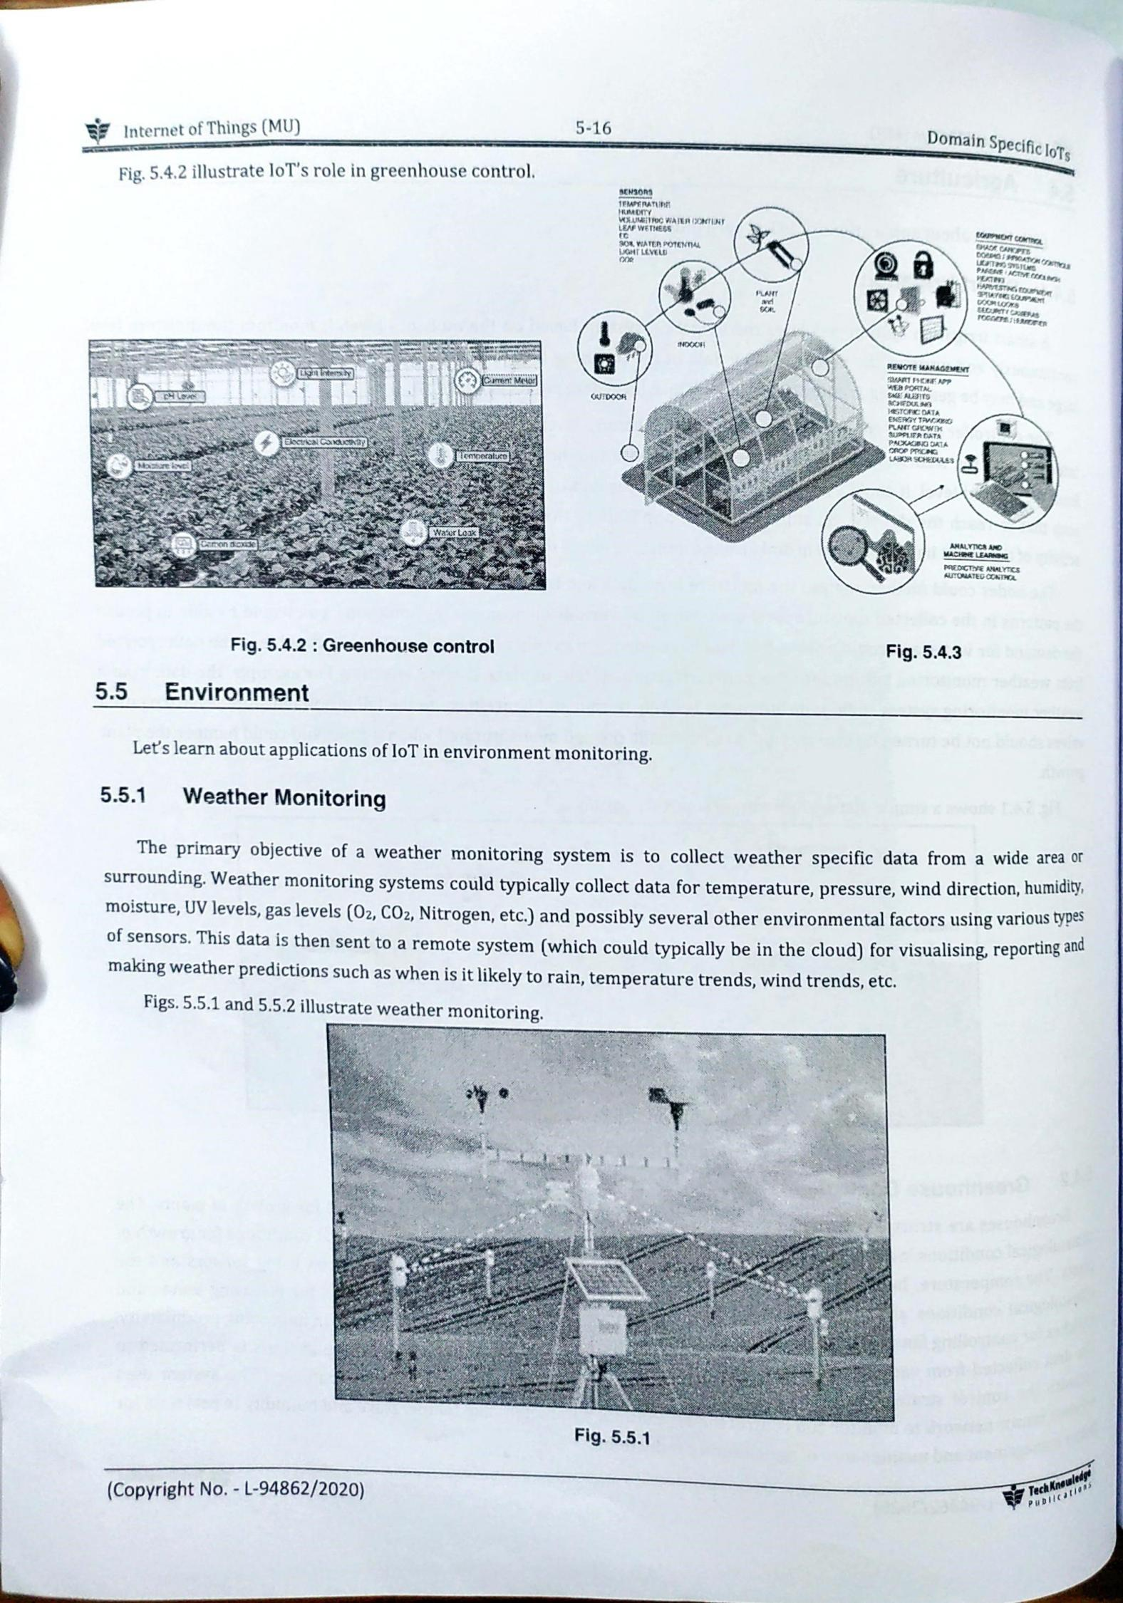

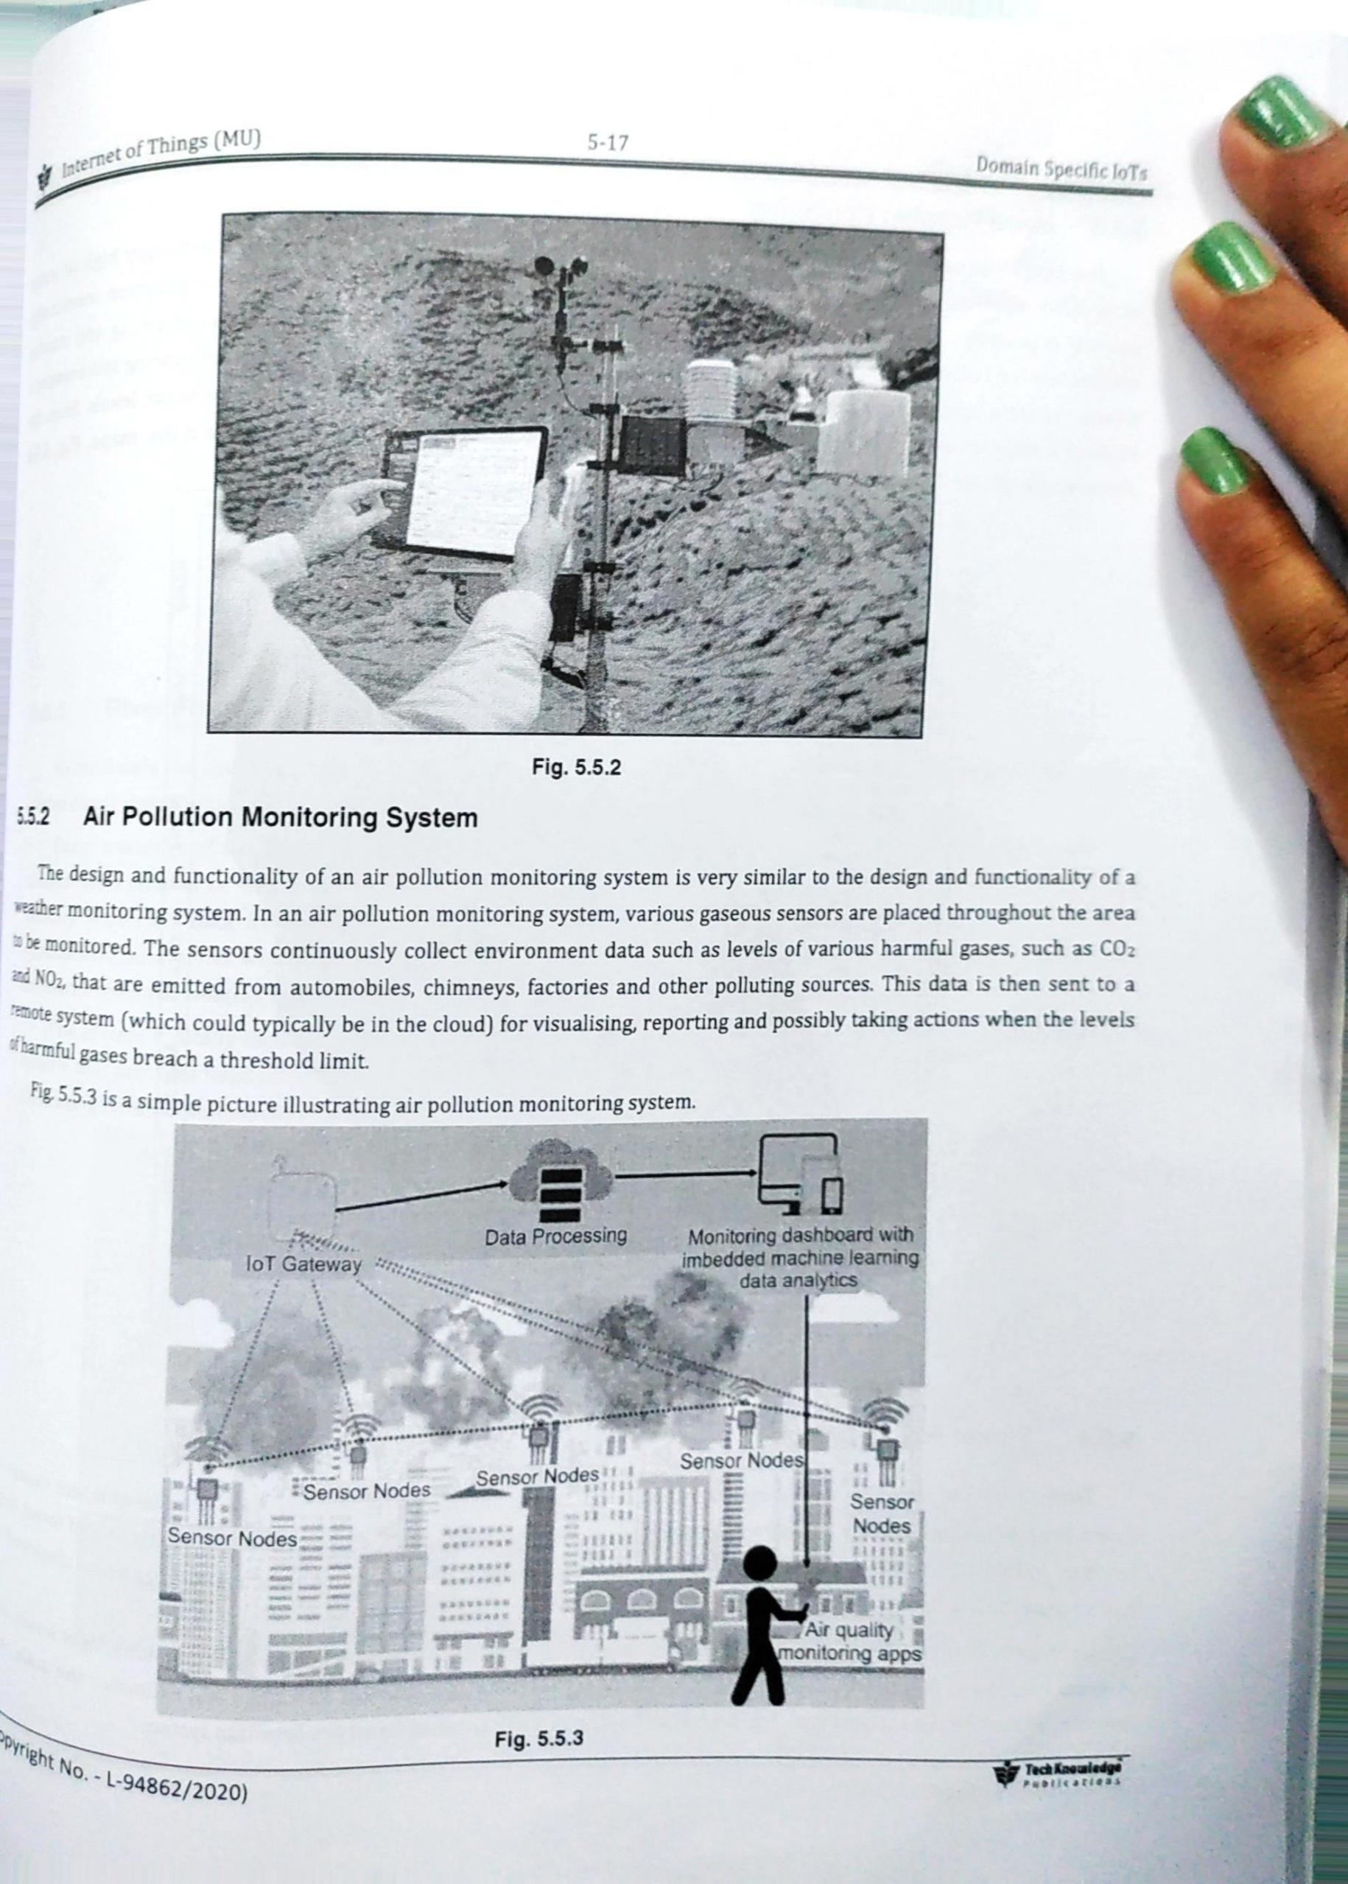

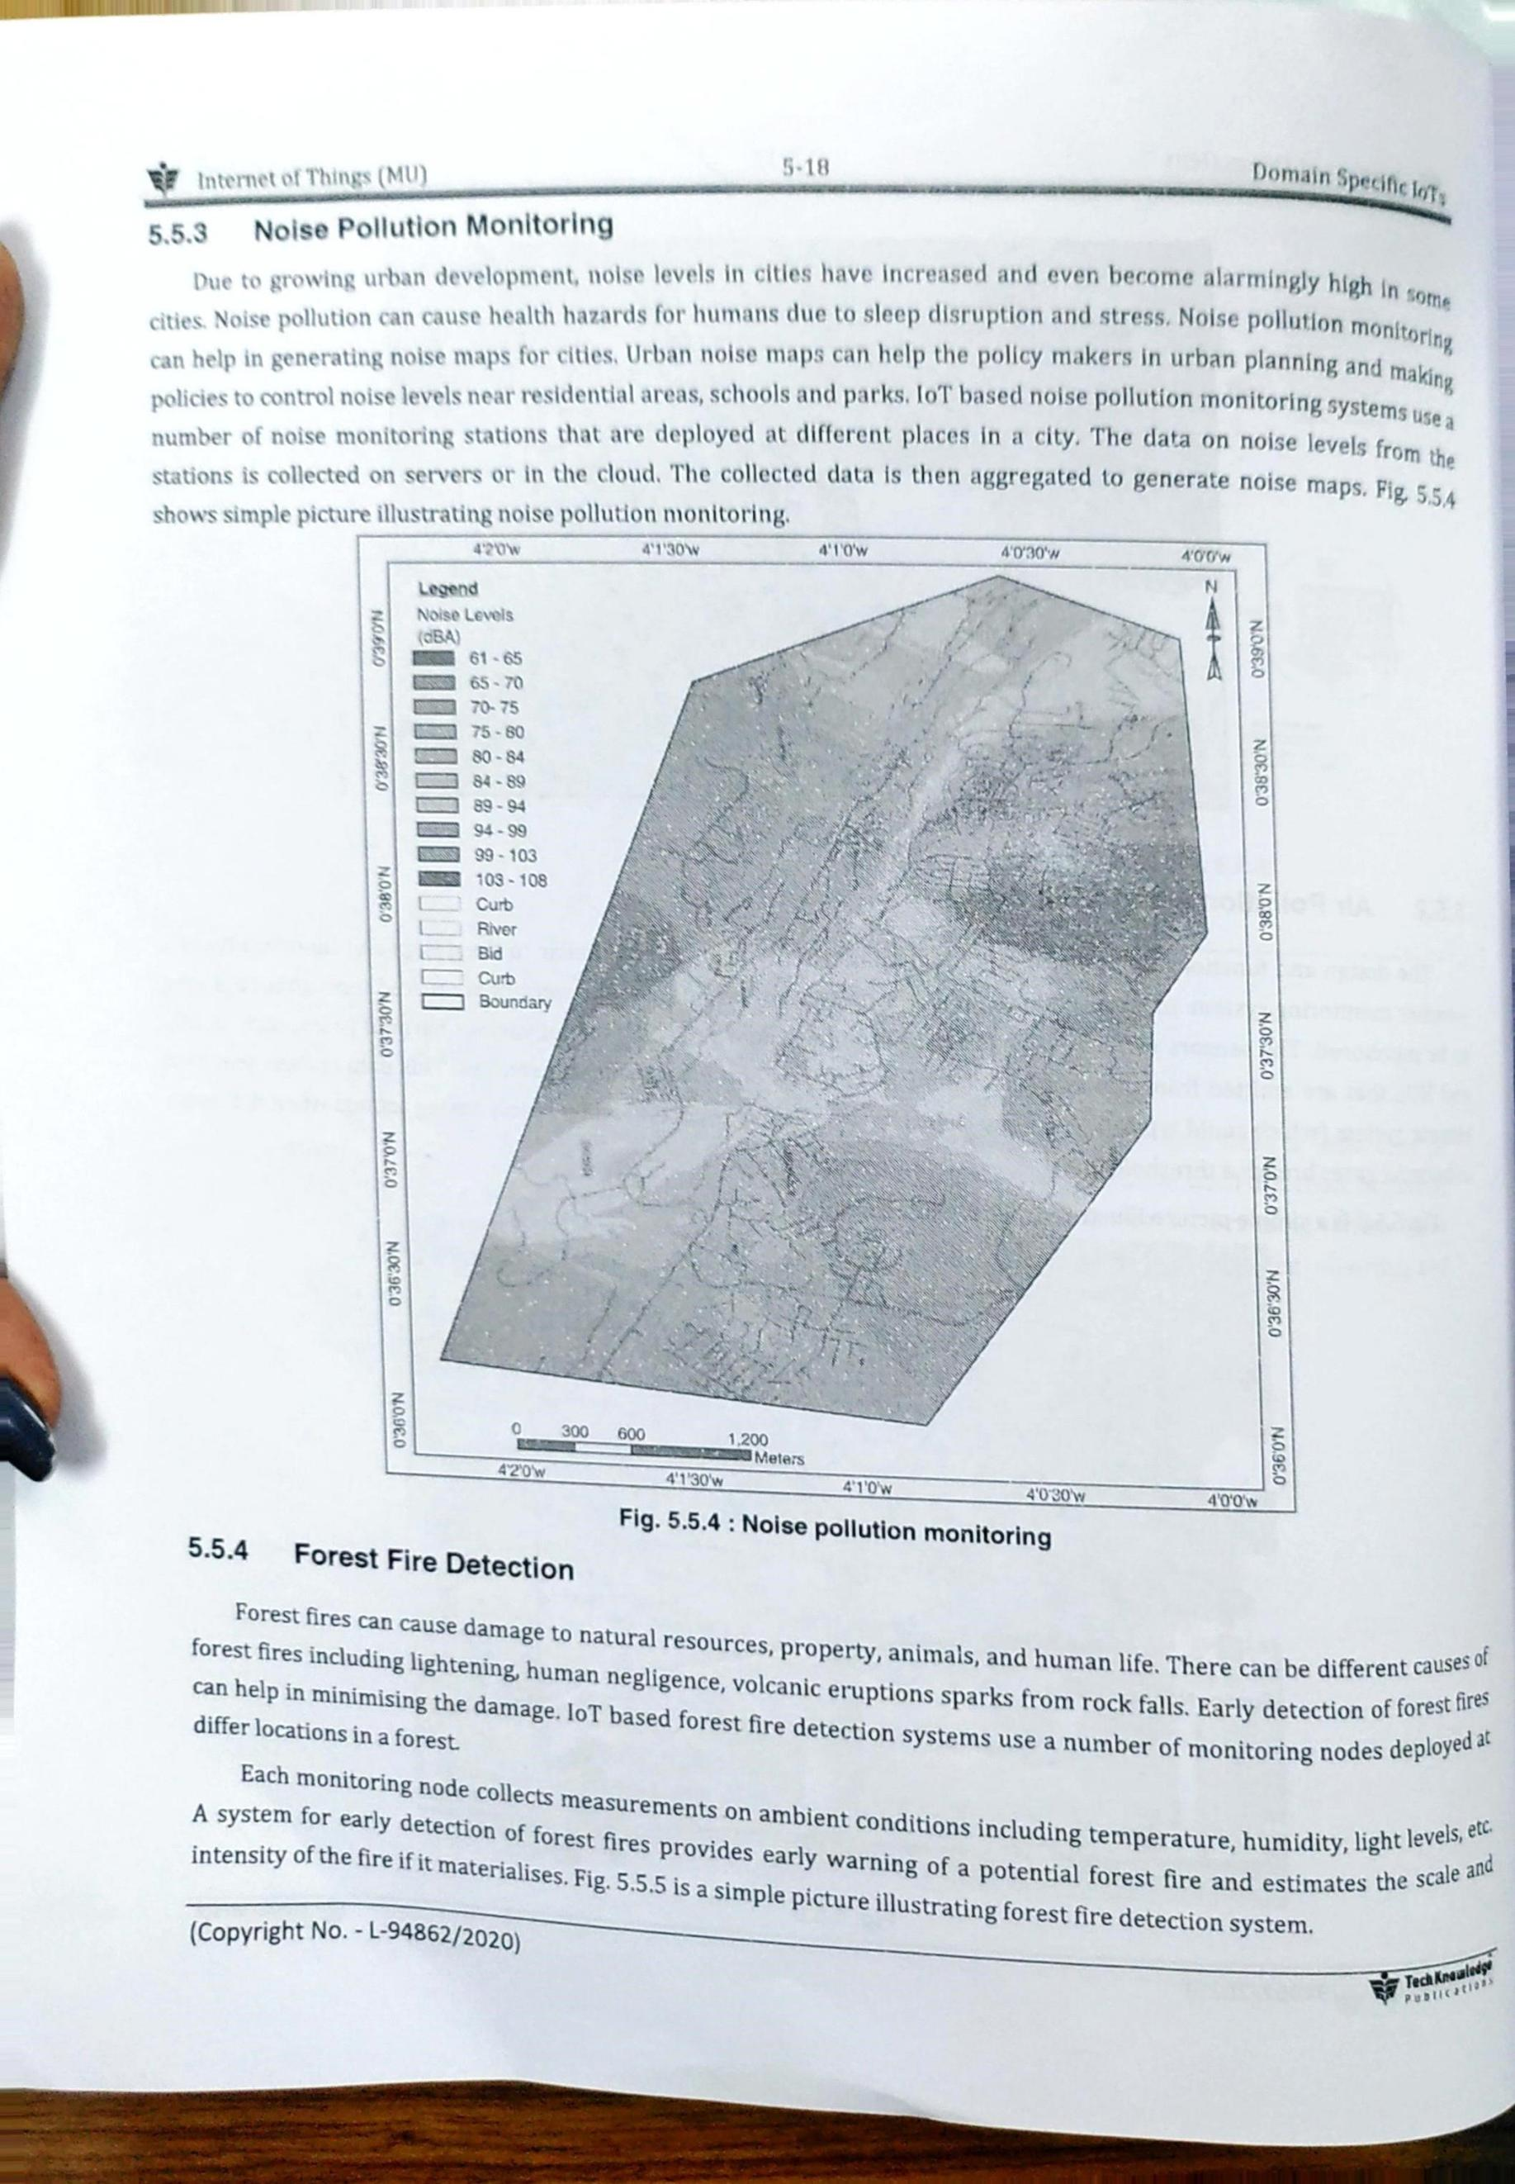

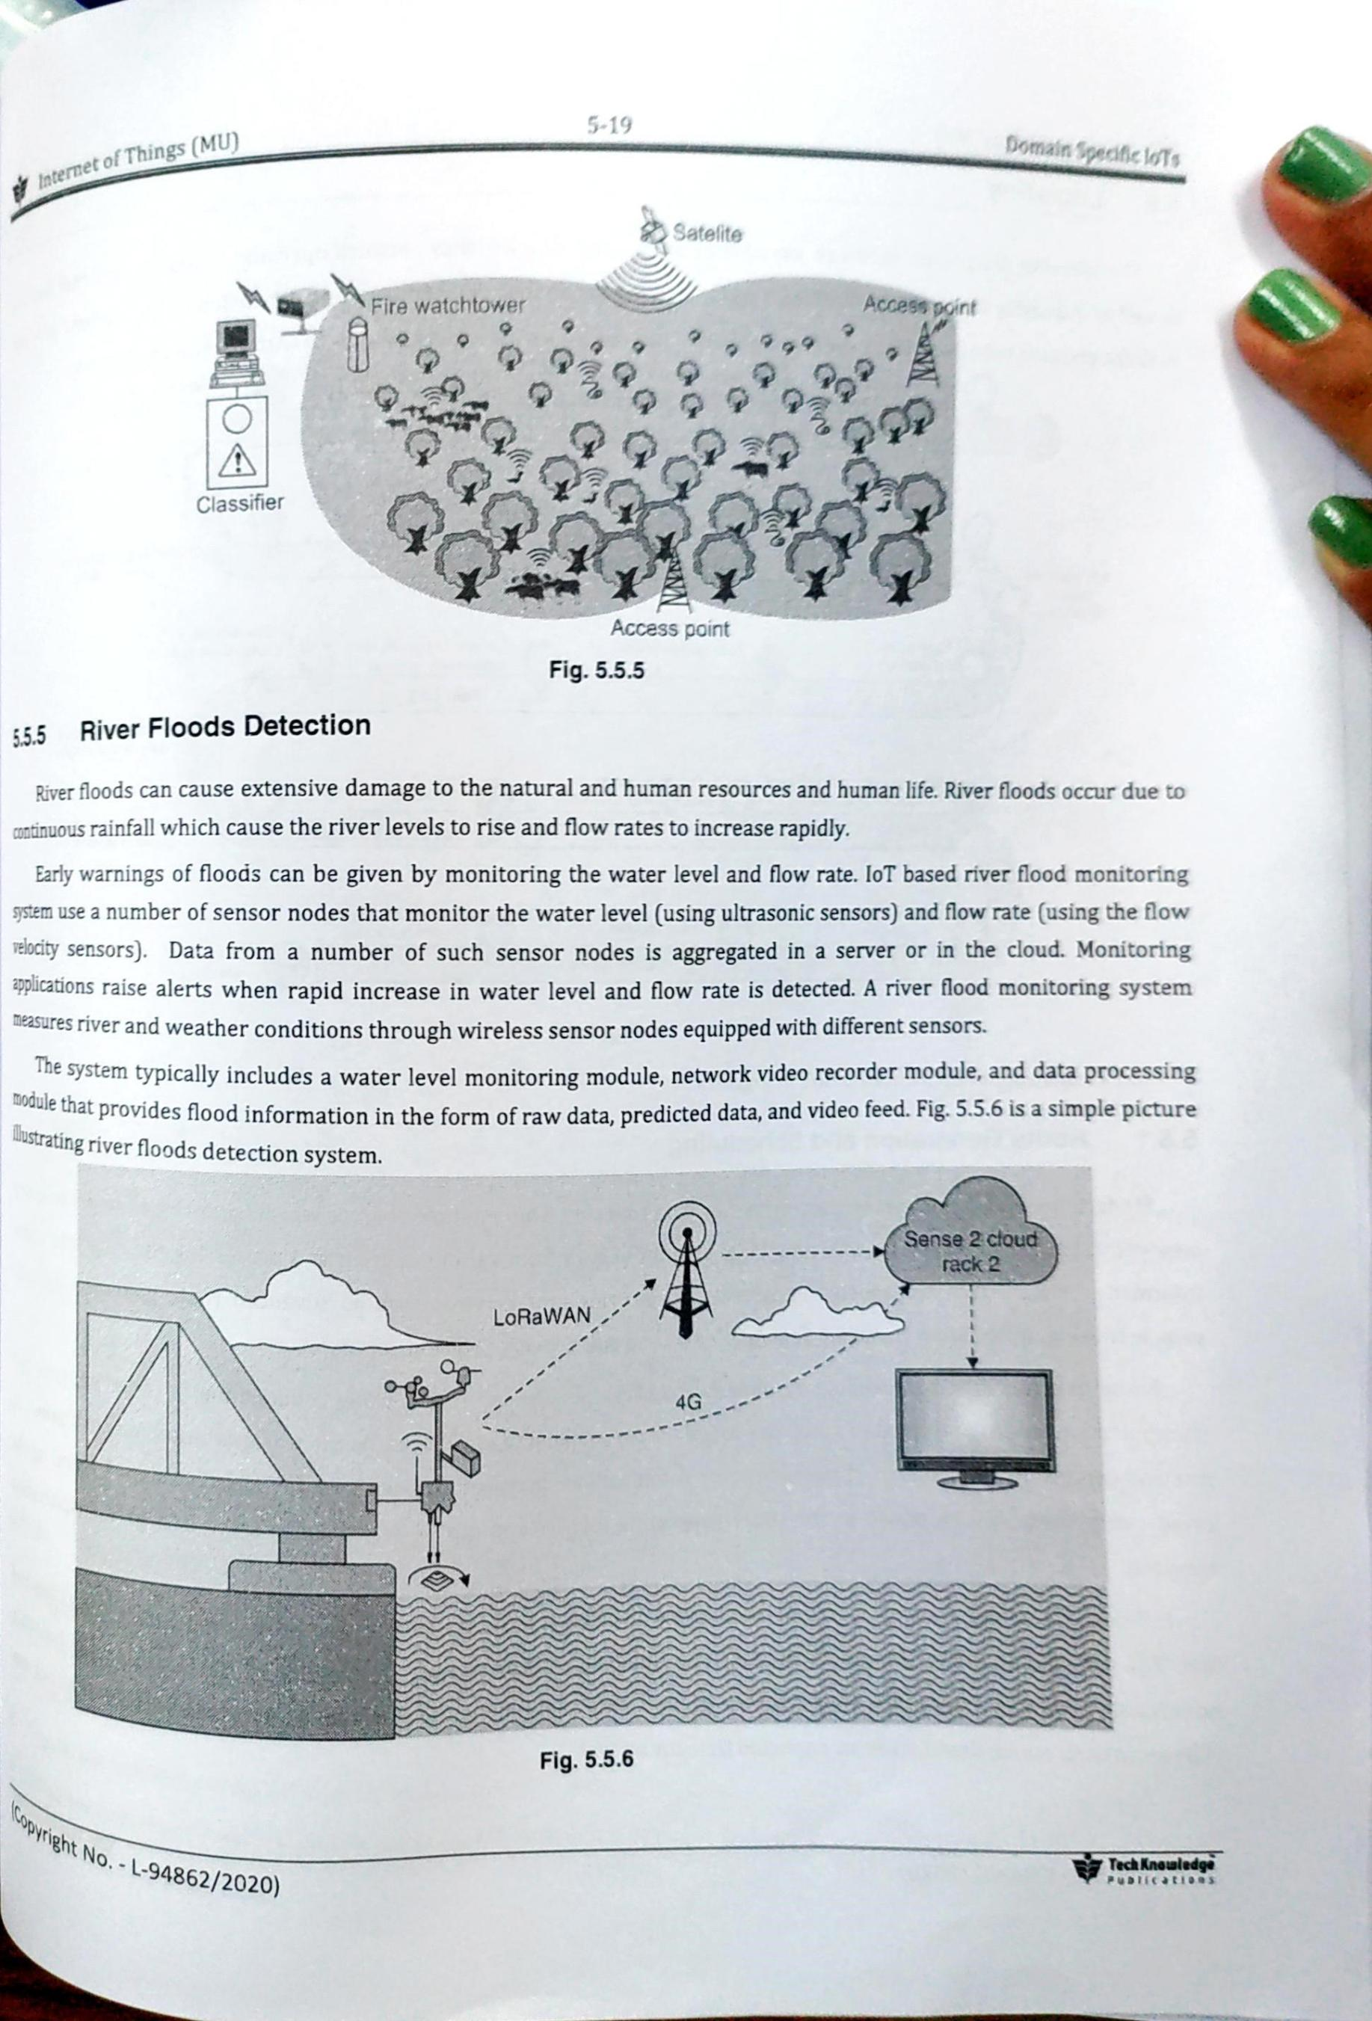

1. IoT smart city

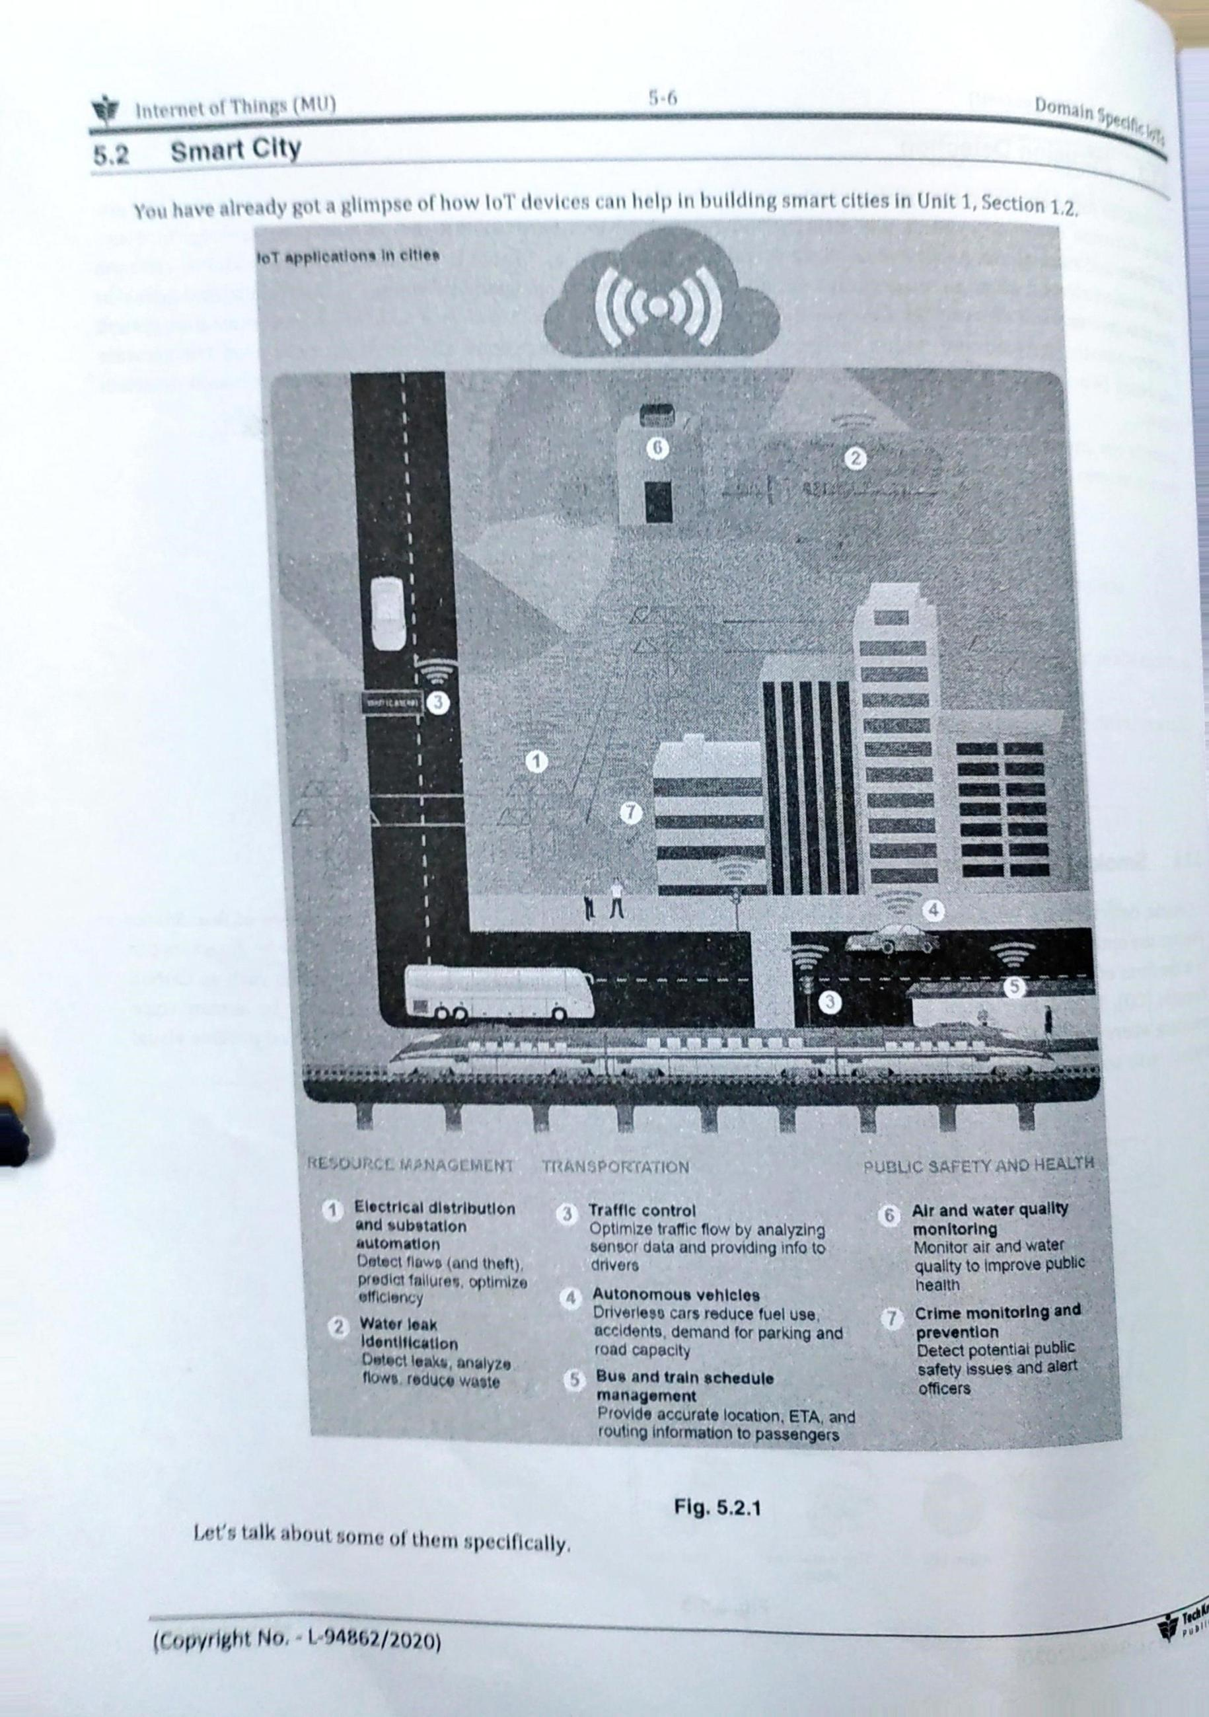

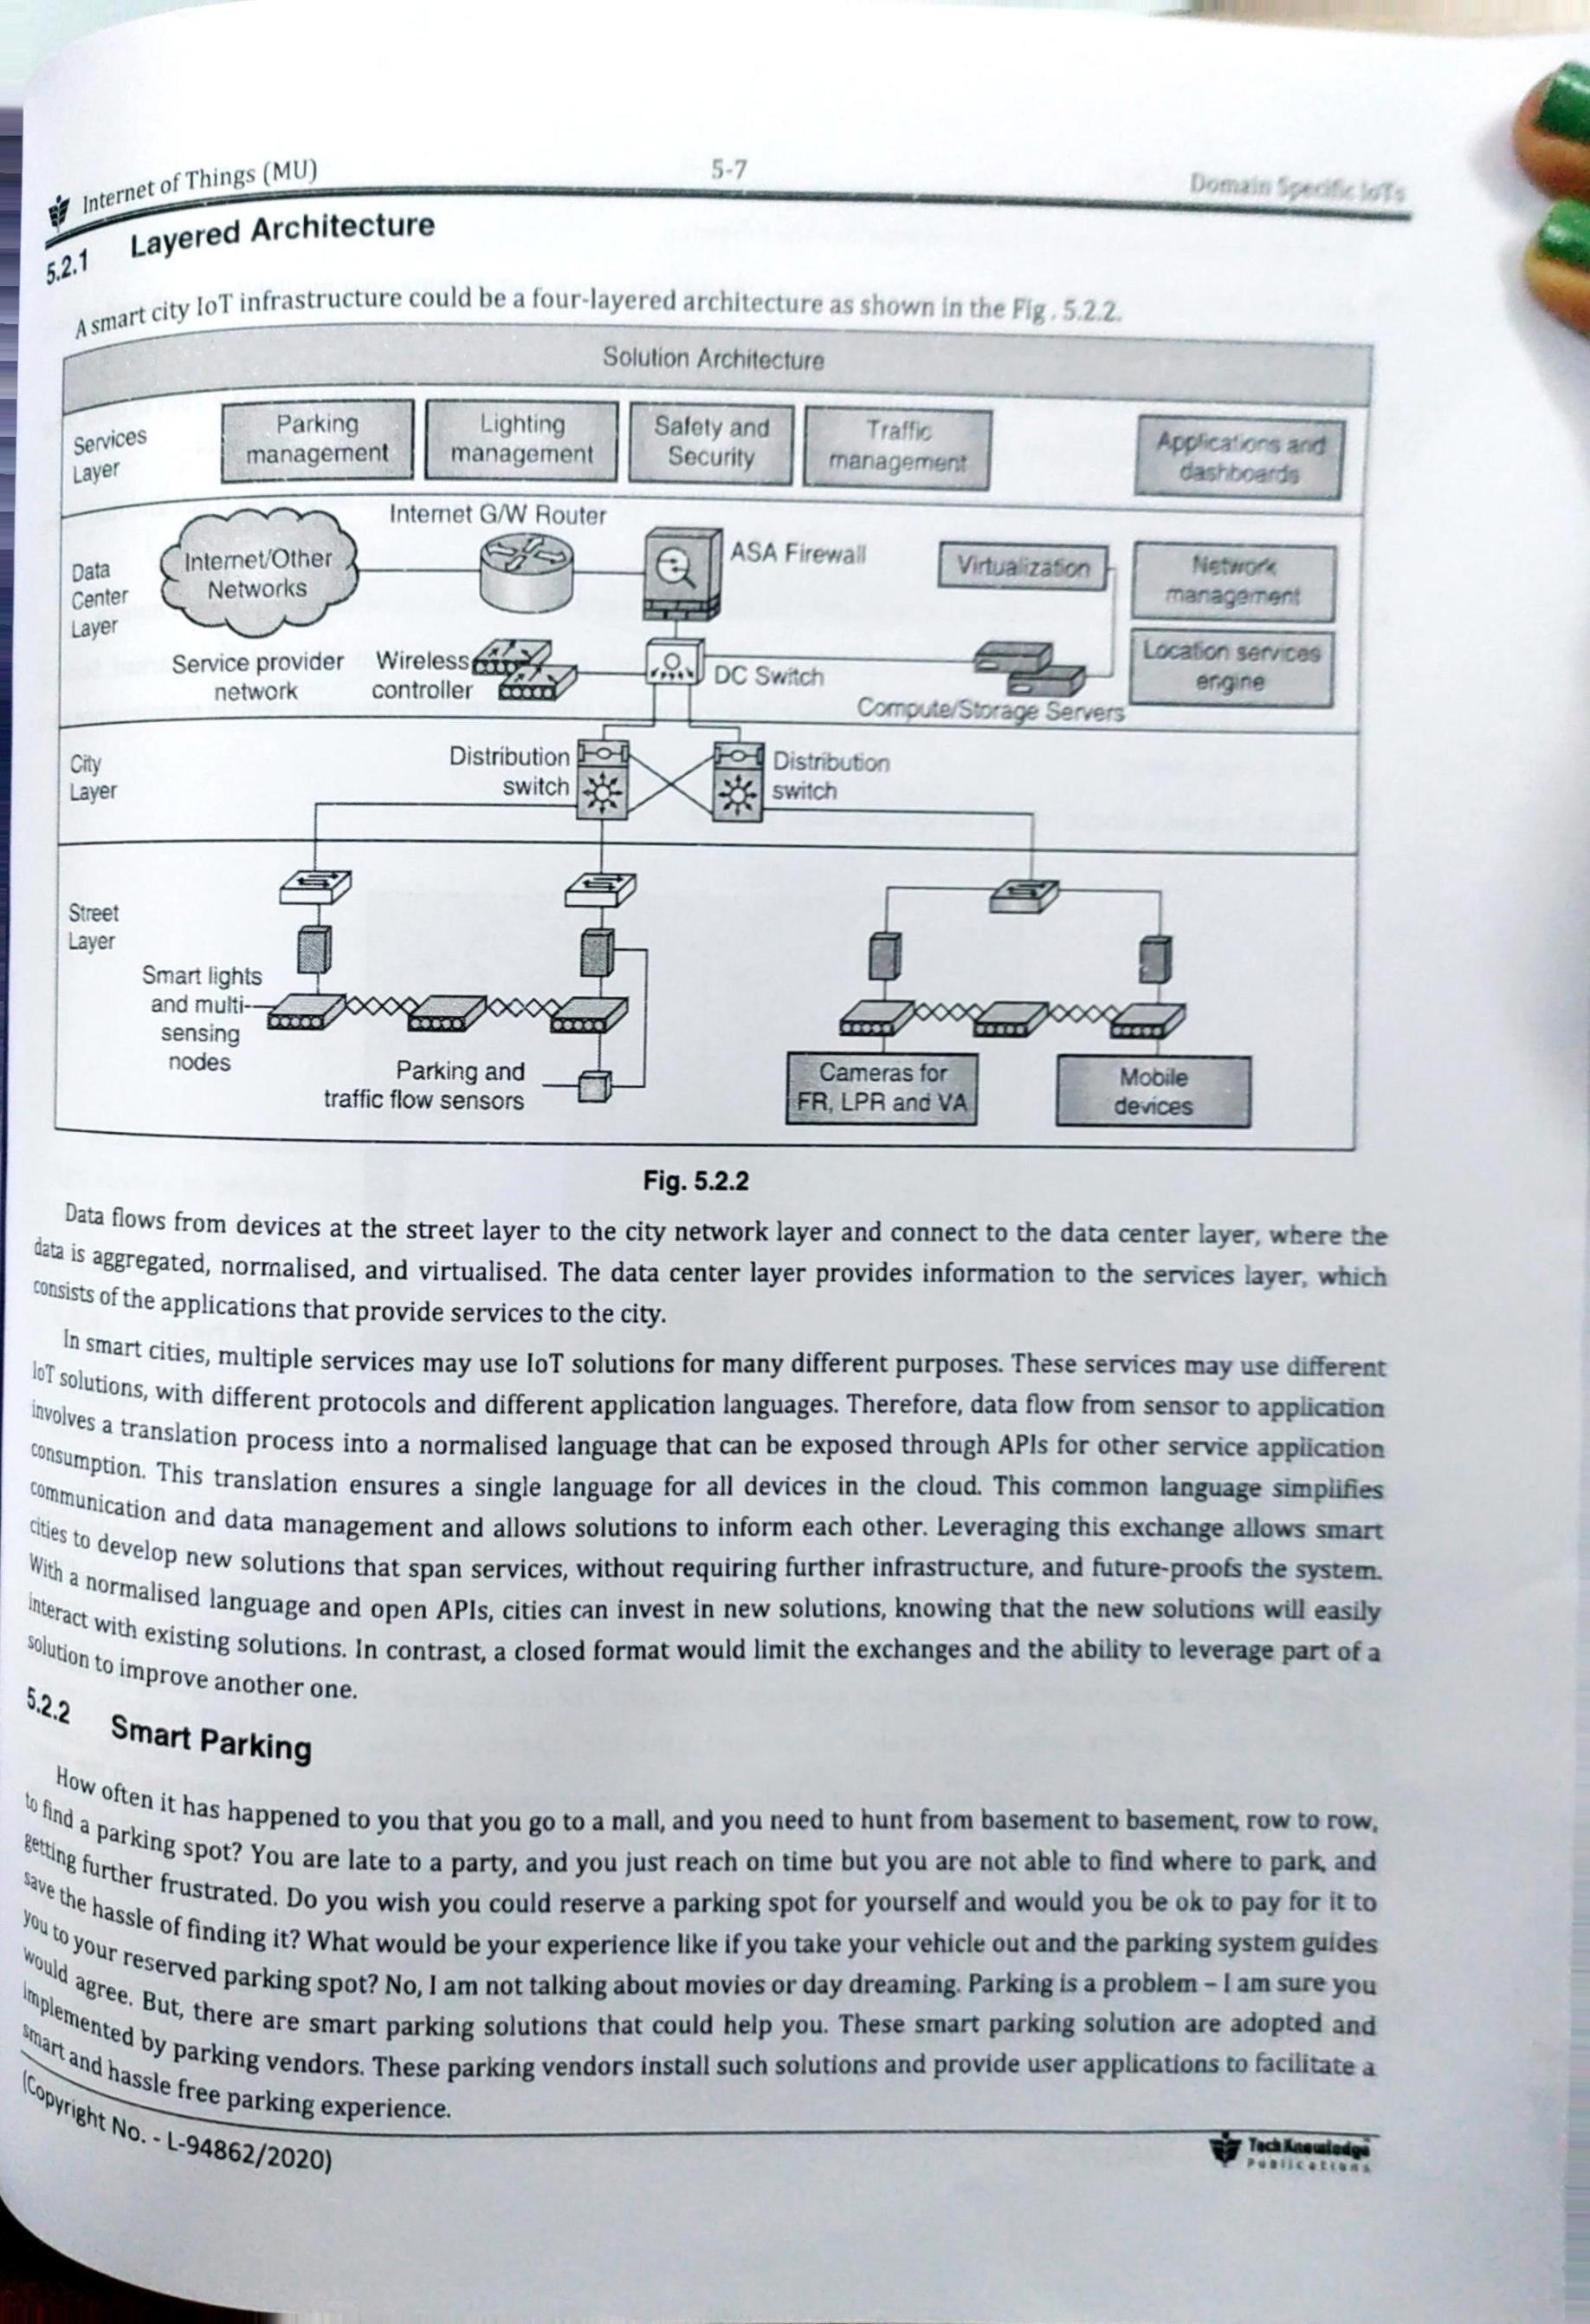

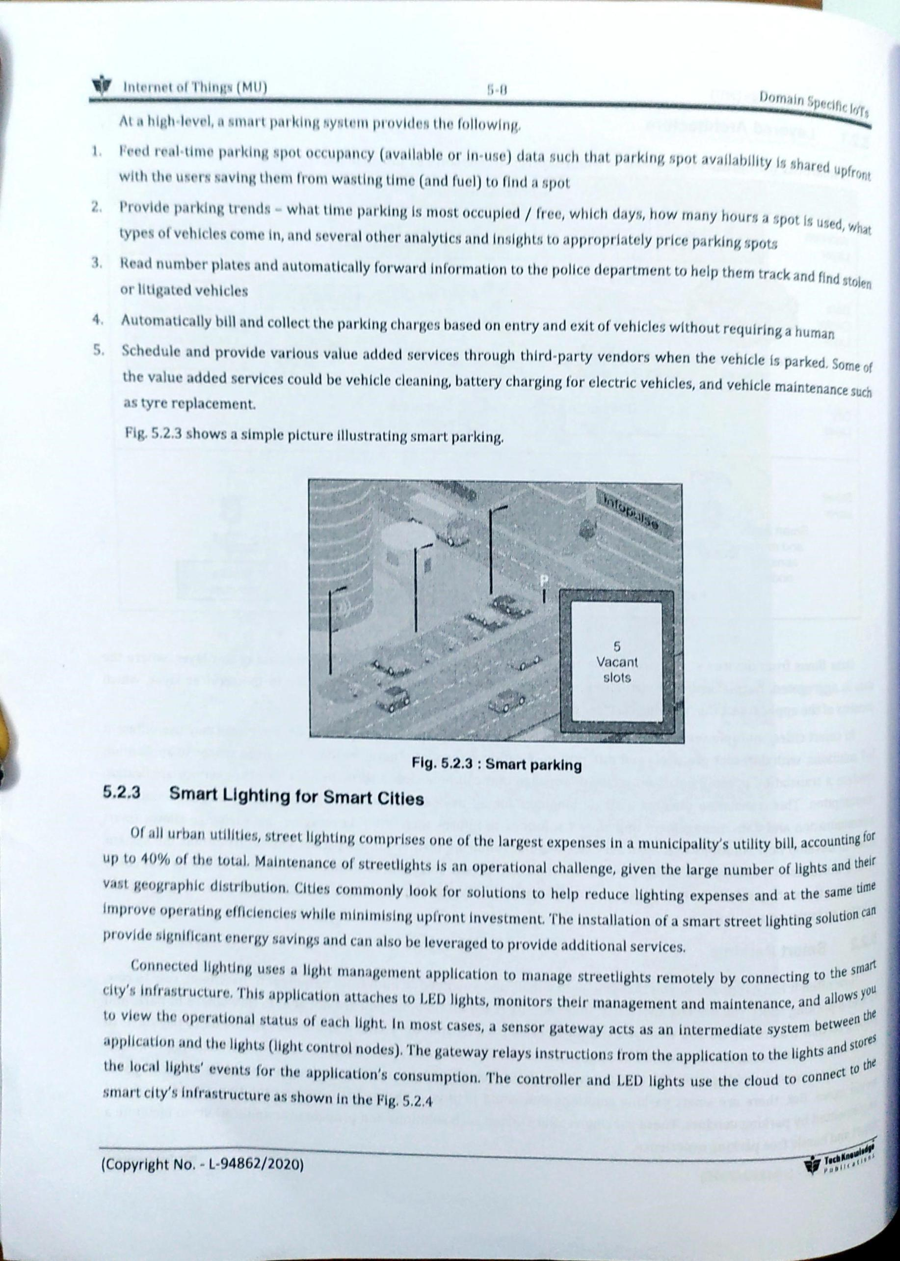

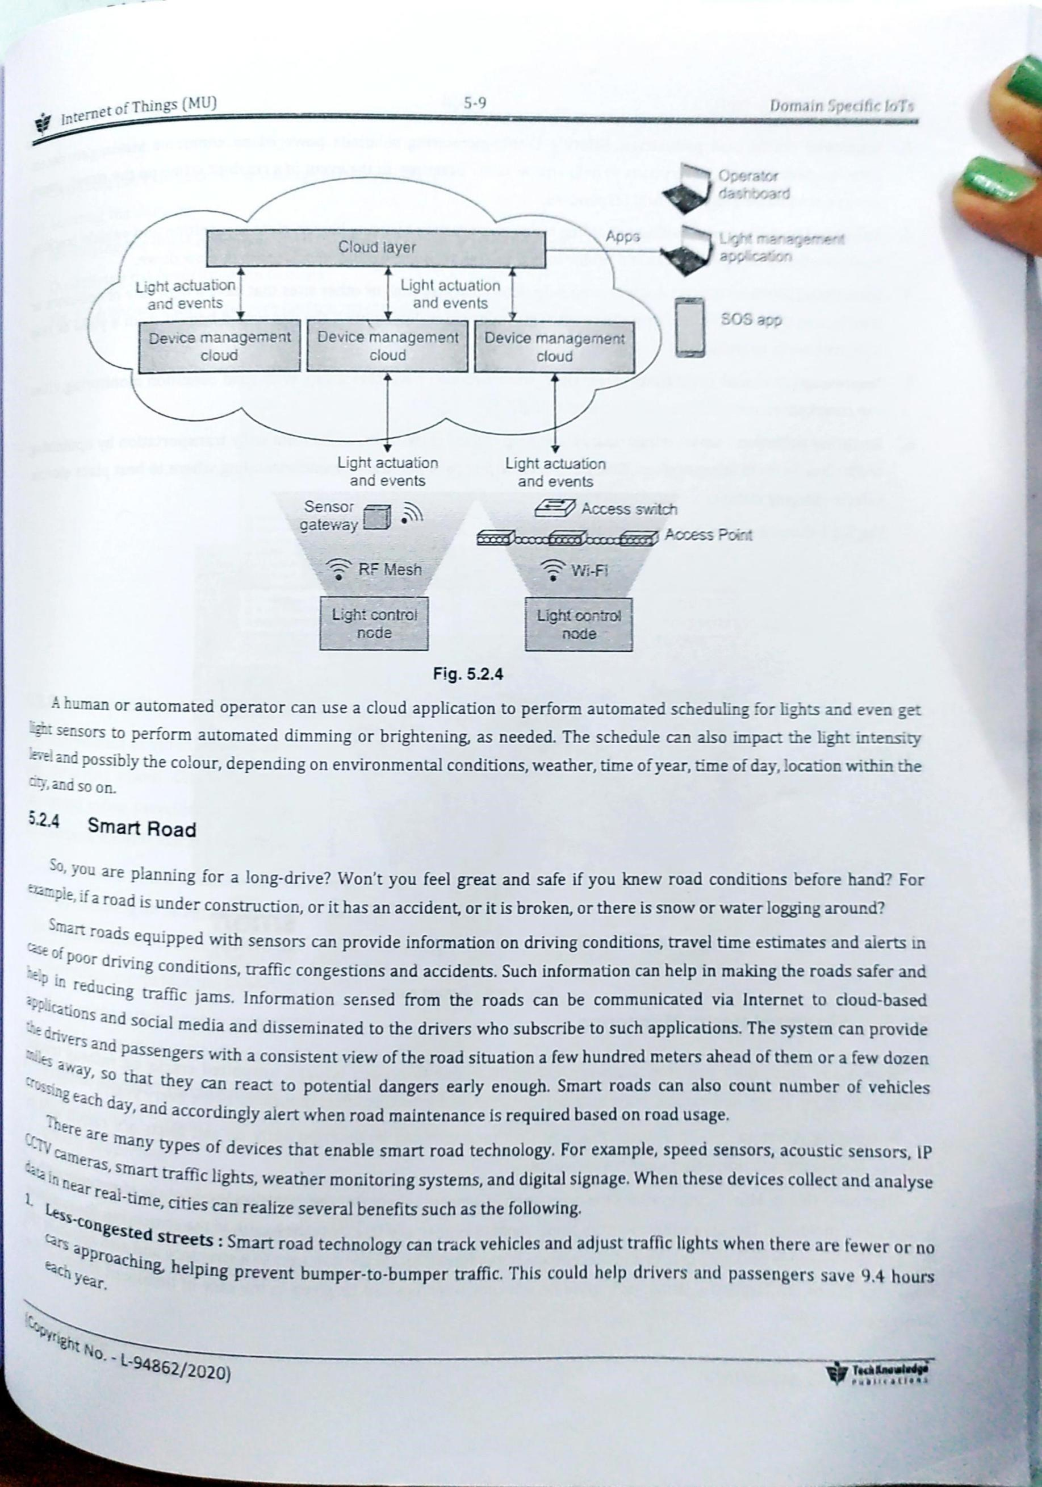

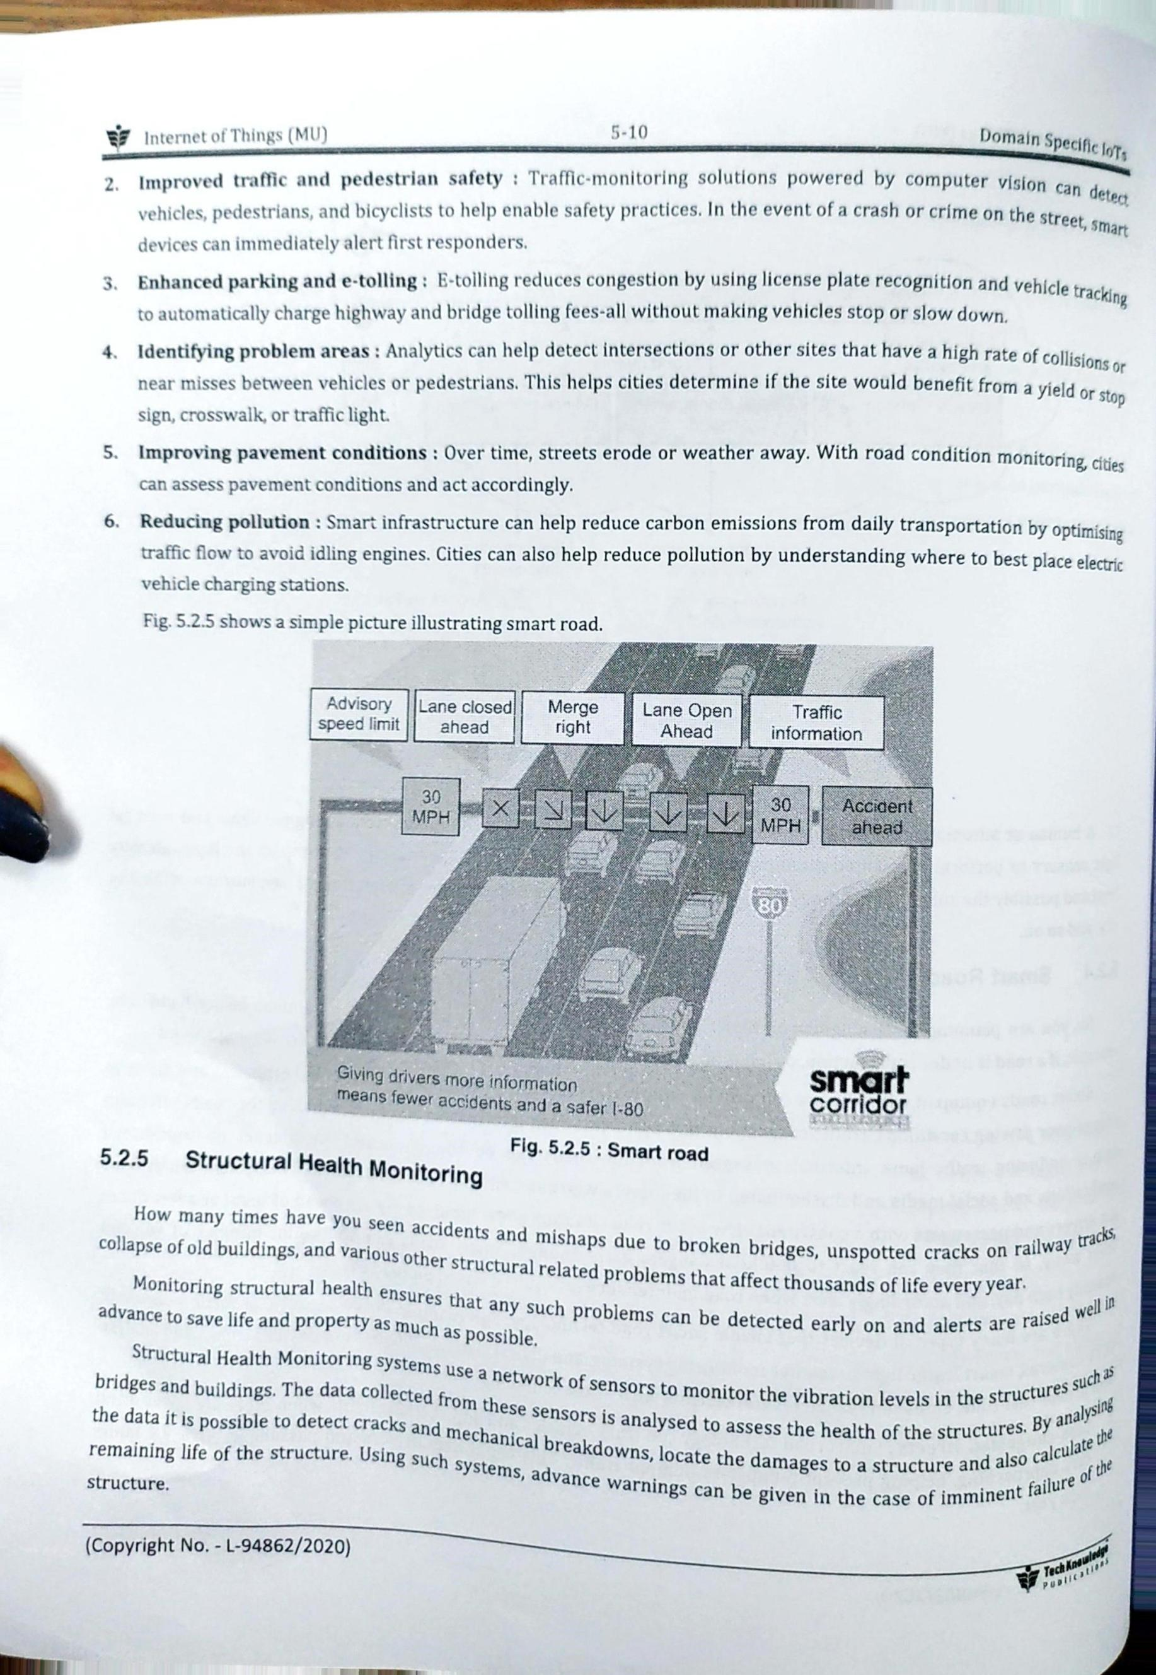

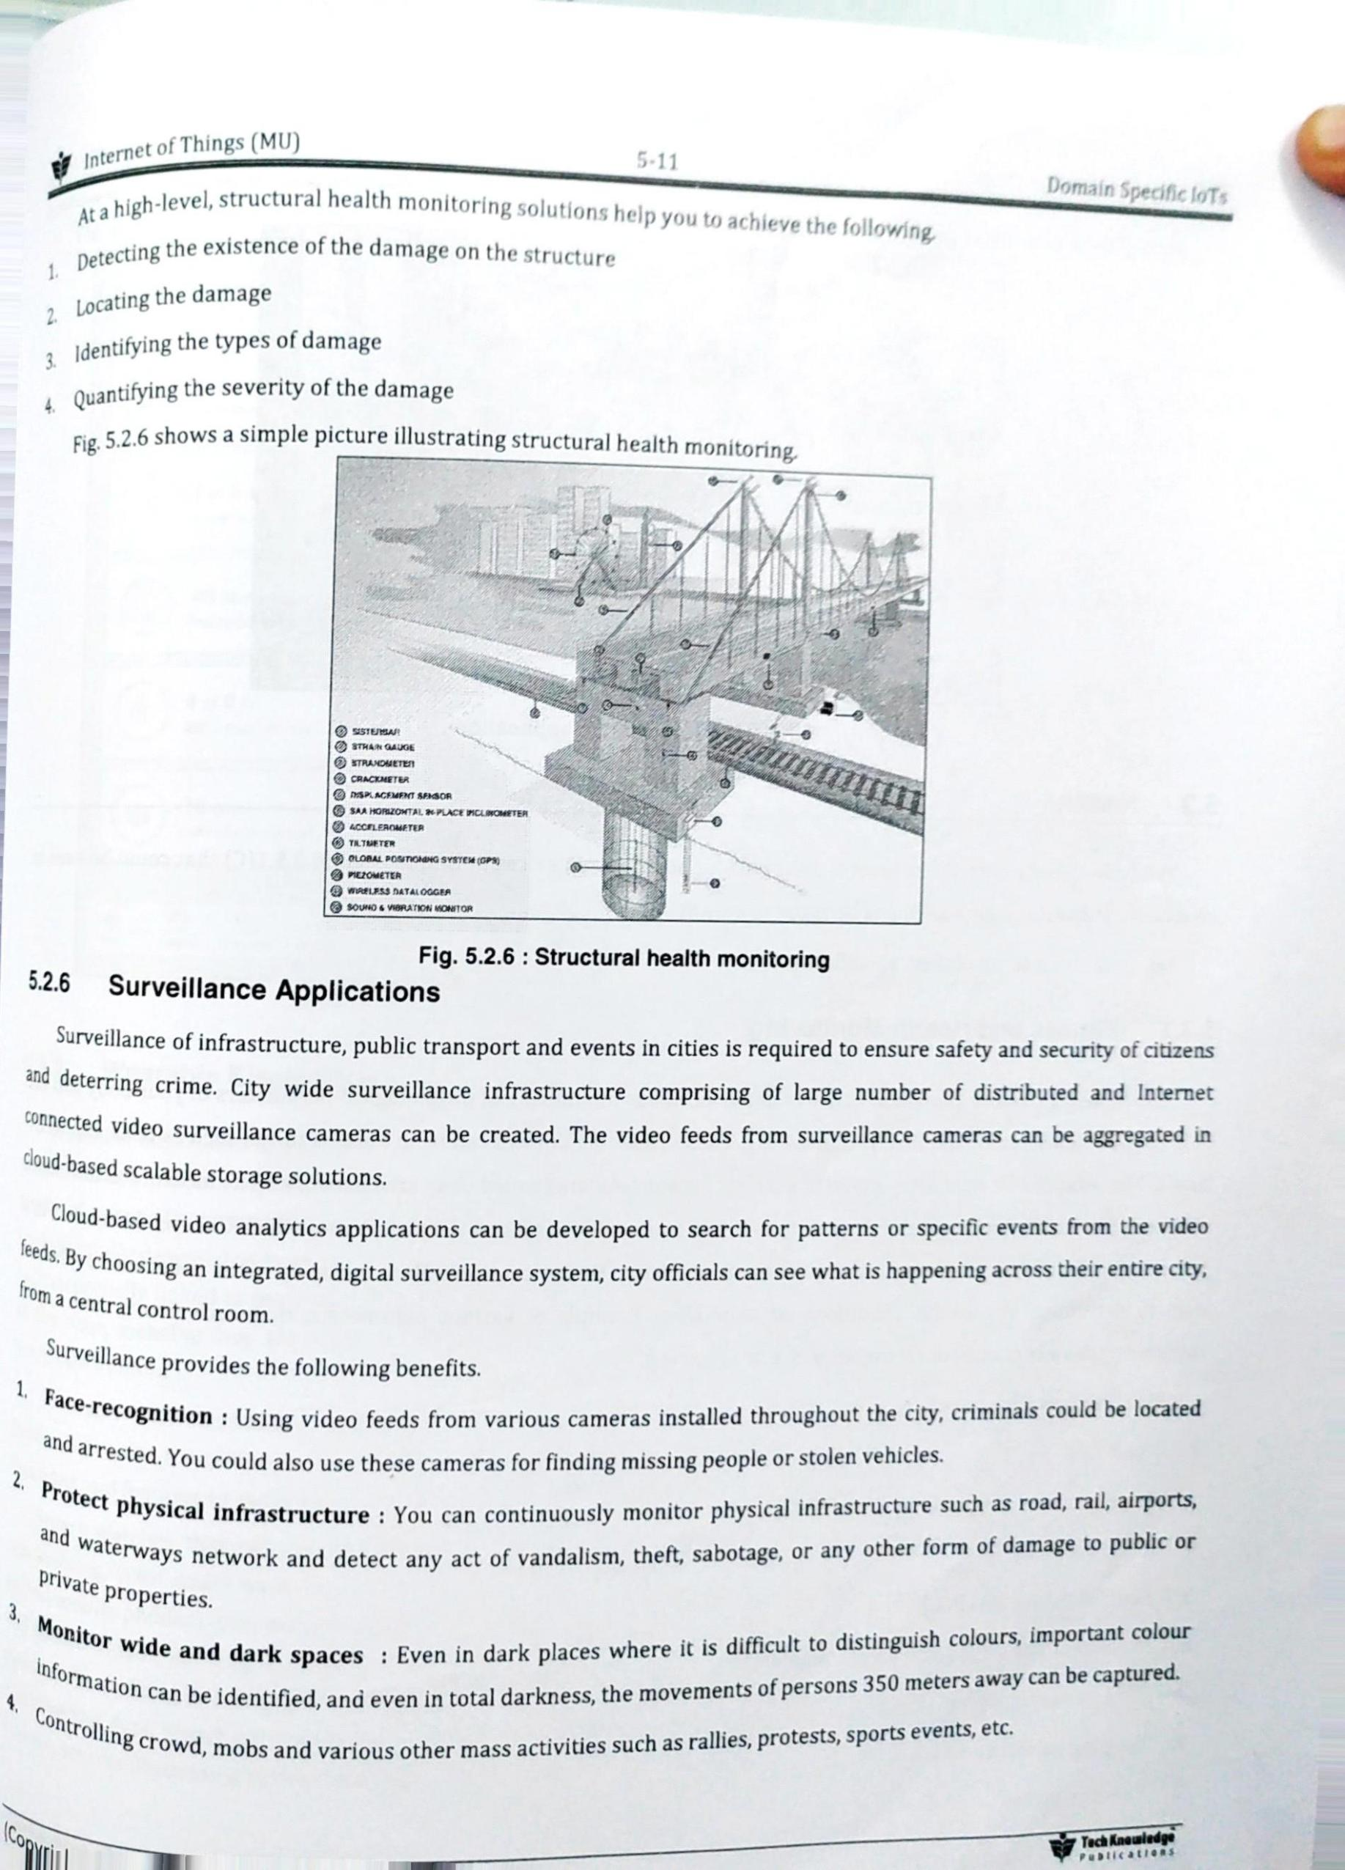



Q2. Compare:

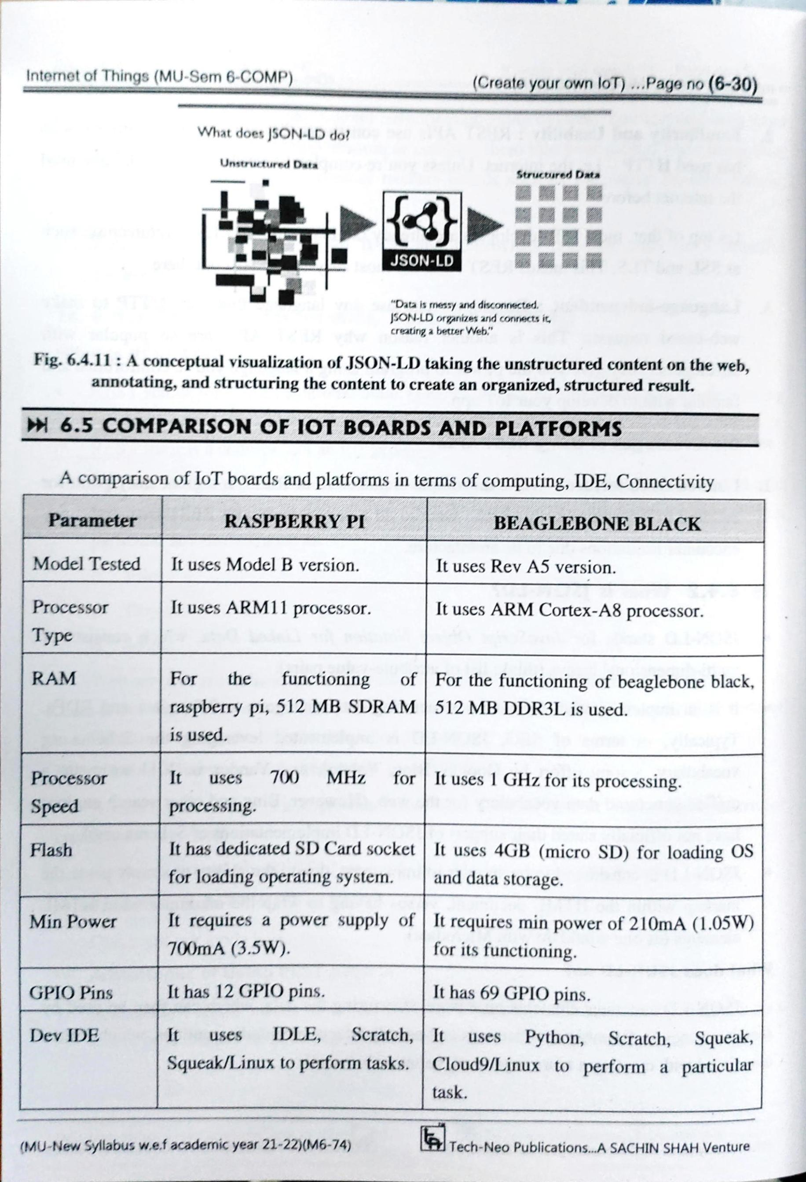

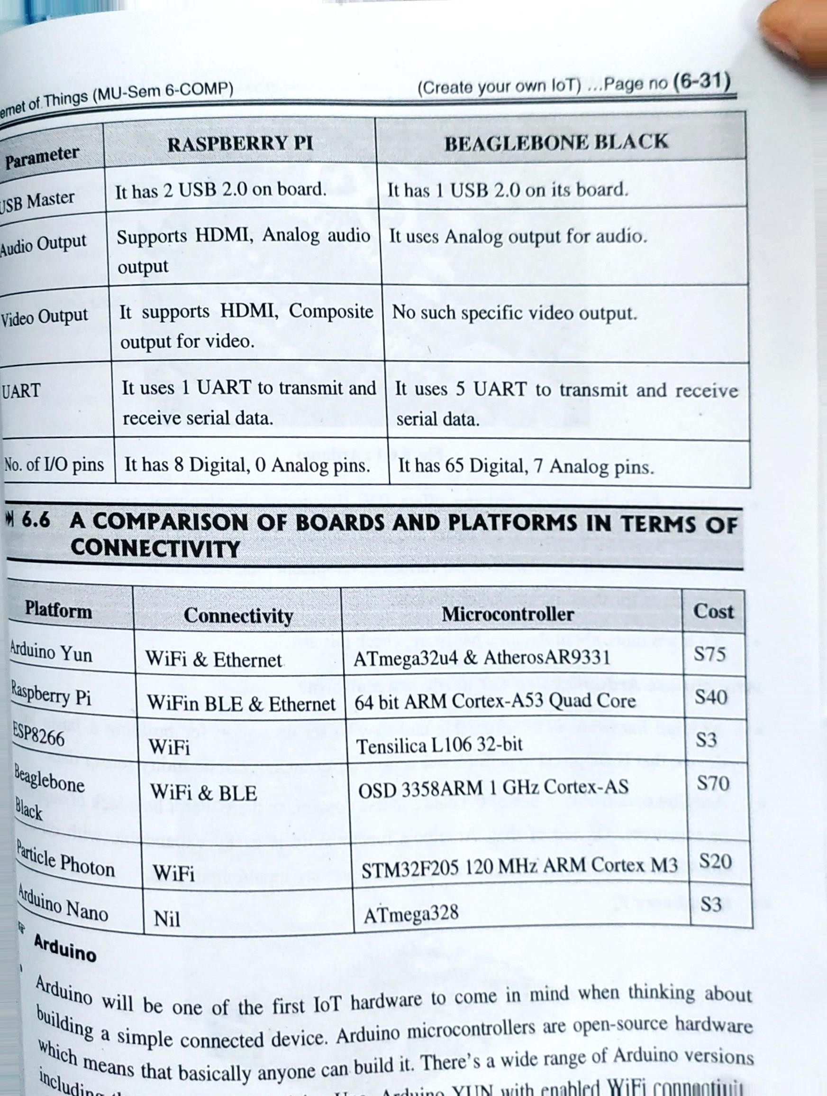

**Q4. Theory Question**

**How to select a suitable IoT Board for your**

**application?Justify your answer.**

**(Note: we r assuming this would be the theory question)**

One way to get started is to consider the key IoT device characteristics in light of your application requirements, and then work through the following design decisions:

Determine the type and number of peripheral sensors and output components that you need, and, if necessary, any design circuits for these components Select a microcontroller or single-board device to co-ordinate reading from and controlling the peripheral components Decide on the data communication protocols that you need to use for intra-device communication (for example, using I2C for communication between the microcontroller and any attached sensors).

Select the networking hardware and protocols that you need to use to communicate with cloud services and apps, For example, to set up a home automation system on a budget, you may choose the Raspberry Pi Zero W. It is a small and very low-cost SBC device with ample processing power and memory (1GHz ARM6 processor and 512 MB RAM) to perform data processing and analytics on the device. It supports micro-SD card flash memory expansion up to 64GB for storing programs and data. And, it is equipped with a full 40-pin GPIO header, just like the Raspberry Pi 4, which allows connecting multiple sensors and supports both SPI and I2C protocols. It has on-board wifi for connecting with a home network, and it can be powered with micro-USB off a portable power pack or wall power supply.

As you progress further with your IoT landscape design you may stop and compare your anticipated performance with design intent. Conduct device design and prototype, embedded software selection, and the selection of upstream services and apps, but then stop to assess it. You can periodically assess your prototypes against your functional and non-functional requirements, including performance, reliability, and security, and revisit these choices as necessary.

**IoT hardware requirements for deploying your IoT project**

IoT devices are highly specialized. They are designed to operate within very specific environments. The hardware for IoT projects vary widely. While you may prototype with generic off-the-shelf hardware, you eventually can move toward the design and development of custom PCB and components, tailored to the requirement of your IoT solutions. As part of this process, you will need to consider these kinds of hardware requirements:

* • Security requirements
* • Ease of development
* • Data acquisition, processing and storage requirements
* • Connectivity requirements
* • Power requirements
* • Physical device design
* Cost Requirements

**Security requirements**

Security is critical element within IoT. It is imperative that it be considered at all stages of design and development. Data integrity and security captured by any device must remain intact - even during prototyping. Security requirements apply to the IoT devices themselves, your network, and the cloud, mobile and web service applications.

**Related security requirements include:**

Ensuring that each device has enough processing power and memory to be able to encrypt and decrypt data and messages at the rate that they are sent and received. Ensuring that the embedded software development libraries support whatever authorization and access control mechanisms are used to authenticate with upstream services and apps.

Choosing to adopt off-the-shelf devices that implement device management protocols for securely registering new devices as they are added to a network to avoid spoofing, and those that include firmware capabilities to support secure over the air updates for security patches

**Ease of development**

While prototyping, ease of development is another high priority requirement so that you can quickly and easily get your IoT device up and running, capturing data, and communicating with other devices and the cloud.

Consider the accessibility, availability, and quality of API documentation, development tools, and support offered by the hardware manufacturer or by the development community. Select devices that are quick and easy to program and re- flash, as well as being low touch to deploy, with zero or minimal per-device configuration required, to cut down on frustration and save time while you are

developing your IoT solution.

**Data acquisition, processing, and storage requirements:**

The number of sensors that are connected, the resolution of the data that is captured, and the rate at which the data is sampled all determine the volume of data to be processed, which impacts on data processing and storage requirements. The amount of data that needs to be retained on a device is dependent on how frequently the device connects to transmit data upstream. A wired, always-connected device that is installed in a smart building, one that streams low volumes of raw data directly to a highly available server, will require less data processing power and storage compared to a device that needs to process large volumes of data in bursts. A device that only connects every few hours to conserve power will require more storage to log data locally in the interim.

**Connectivity requirements**

Connectivity requirements for wireless networking include operating range, how far the signal will need to be transmitted, and the anticipated volume and rate of data to be transmitted. Consider fault-tolerance and the ability for a device to reconnect and retry sending data, after it was disconnected.

Your hardware may have integrated network connectivity like Bluetooth or WiFi, or this capability might need to be added with an expansion board or module. An external module that can be upgraded can provide more flexibility, as you have the option to try different modules to evaluate their range and power consumption.

**Power requirements**

Many of the other requirements, including the number of sensors needed, and the rate of network transmission, will impact the device’s power requirements. Consider whether your device will be hardwired for power, or require a portable power source like a battery or super capacitor. If it requires a portable power supply such as a battery, you need to know the size, weight, and capacity requirements for the battery, as well as whether it must be rechargeable, replaceable, or discarded after the battery dies. If the device is rechargeable, how often should be charged, and by what means?

**Physical device design requirements**

The physical device design requirements include the appearance and size of the device.

The environmental conditions in which the device will be installed also need to be considered, for example, will it need a waterproof or ruggedized enclosure? For example, a device that is installed on the underside of a truck as part of a fleet monitoring application would need to be shielded to ensure it continued to operate under harsh conditions; it would need to be waterproof and resistant to dirt, shock, and vibration.

**Cost requirements**

The cost of the hardware includes the initial outlay for the hardware and associated components (such as any sensors) as well as their on-going operating costs, such as power and maintenance costs in the form of replacing worn parts or defective components. Also consider possible licensing fees for some components or device drivers. Purchasing commercially available off-the-shelf development boards or SBCs may be more economical than fabricating custom boards. As you scale out your IoT network with many devices, dedicated hardware devices may become a wiser alternative.